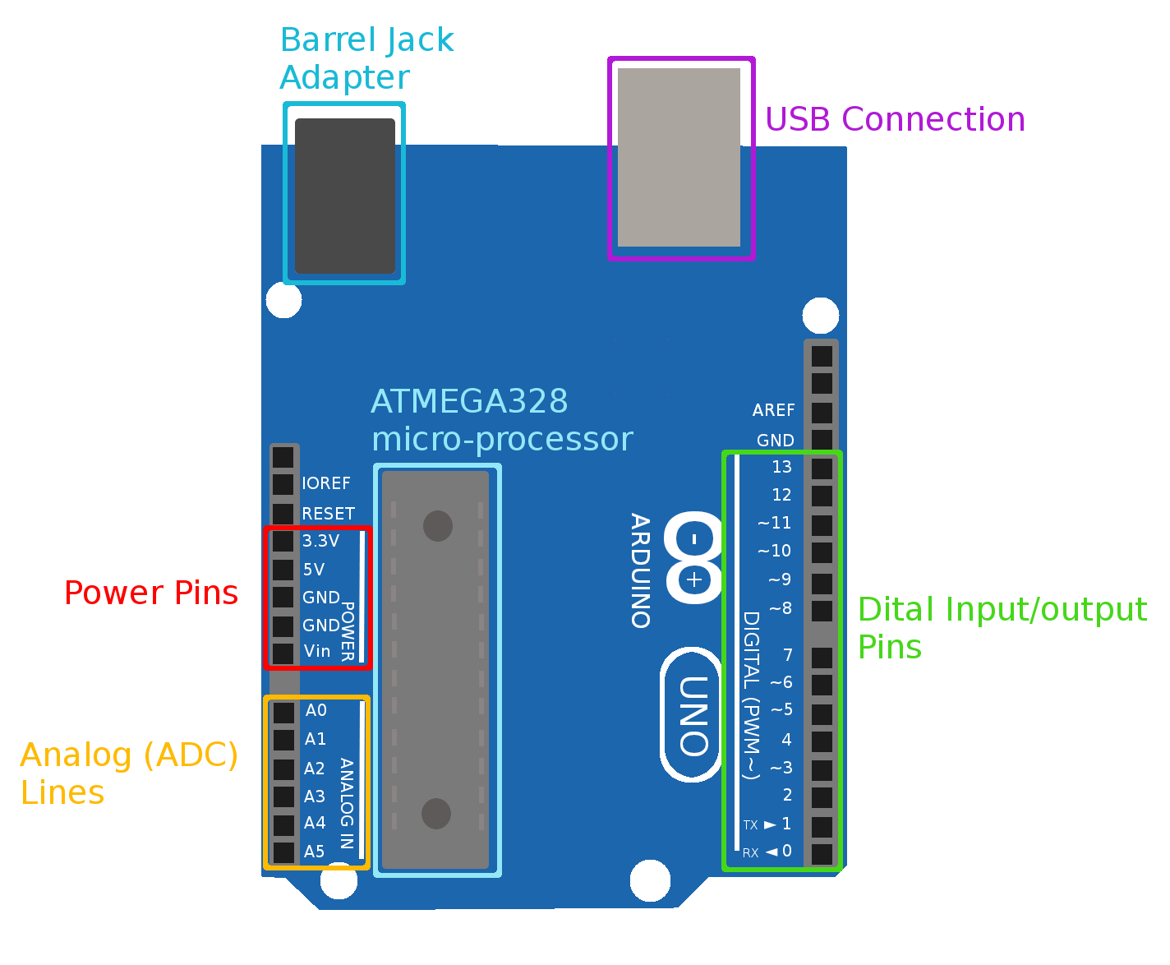
Arduino Components

ATMEGA328 micro-processor – This is the core component of the Arduino Uno. The Adruino iteself is basically a break out board to expose the pins and features of this microcontroller and make them fit into a more accessible form factor.
Barrel Jack Adapter – The Arduino is designed to be powered by many several possible inputs. The easiest is probably this barrell jack adapter, which can easily be adapted to accept power from a 9V battery or from a wall socket.

USB Connection – This is the device which lets us power the Arduino using our computer (or any other USB power source). It also lets us load code and receive debug messages over the serial port.
Power Pins – These pins relate to the powering of the Arduino, and the Arduino's powering of connected devices.
- 3.3V – This pin provides a 3.3V output for powering devices.
- 5V – This pin provides a 5V output for powering devices
- GND – These pins provide ground lines for either powering external devices or powering the Arduino from an external source.
- Vin – This is a 5V input for powering the Arduino.

Analog Pins – The are the ADC input pins. We use them to read data from analog devices. The Arduino is capable of reading data from up to 6 analog devices. These pins are only for analog input, the Arduino does not contains the hardware to create an analog output signal (these devices are called Digital to Analog Converters or DACs).
Digital I/O Pins – These are the general purpose pins of the Arduino that can be used to read or write from a digital device. This means they can, in write mode, either be set to high (3.3V out) low (0V out) when in output mode. Alternatively they can, in read mode, detect when the device connected to them is generating a high or low signal. Some of these pins have additional speacial functions like being used as part of the I2C or SPI bus, or being connected to the hardware serial line. All of them can be used as general purpose input/output (GPIO) pins.

